RFI/P topics
Next Generation Routing/Networking Infrastructure
Table of Content
1. Introduction 2
2. Distributed Disaggregated Chassis 2
3. Open architecture 4
4. Open optics 4
5. Scalability 4
6. High availability & Redundancy 4
7. Cloud-native 5
8. API (application programming interface) 5
9. Multiple ASIC support 5
10. Management & Operations 5
11. Multi-Service over a shared network infrastructure 6
12. LAB POC\FIELD TRAILS 6

- Introduction
The telecom industry is pushing for new solutions to meet the rapid network growth and demand, be able to innovate faster, and reduce cost, [Service provider] would like to adopt webscale technologies and methods based on a new concept like merchant silicon, software-centric solutions, white-boxing, disaggregation, and eliminating vendor lock.
[Service provider] goal is to obtain efficiencies in the network and meet the following goals in the following years:
- Reduced cost per bit.
- Avoid any network supplier lock-in.
- Deployment of homogeneous hardware across all network locations.
- Simplified operation and systems integration based on unique software.
- Accelerate innovation and faster time to market.

A disaggregate, cloud-native approach to networking infrastructure will allow [Service provider] to achieve the above goals.
[Service provider] will then evaluate each supplier for his overall compliance and overall response to pick best-of-breed suppliers for software and hardware.

- Distributed Disaggregated Chassis
At the beginning of 2019 market leaders, Tier-1 carriers with merchant silicon providers, and ODM suppliers submitted to the Open Compute Project (OCP) specifications for a Distributed Disaggregated Chassis (DDC) architecture. Using open merchant silicon chips, the DDC design aims to establish a standard set of configurable building blocks to construct service provider-class routers, from single line card systems to large, disaggregated chassis clusters.
This architecture design is built from the ground up for the carrier’s network rigid requirements, and provides end-to-end functionality from the core, edge peering, and access locations.

In a DDC-RS (Distributed Disaggregated Chassis Routing System), the functional components are redistributed differently than in a traditional chassis-based solution, The router is a collection of physical boxes connected in CLOS architecture and the SW is virtualized or containerized functions.

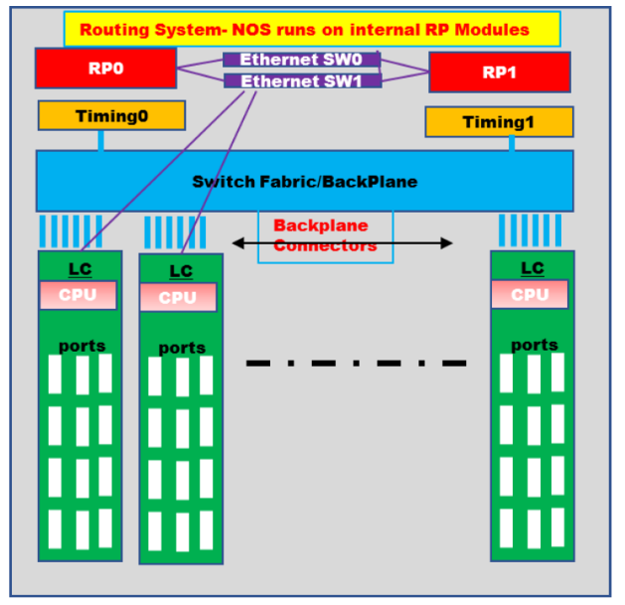
Figure 1 - Open Compute Project - Functional Block Diagram of a Modular Chassis Routing System

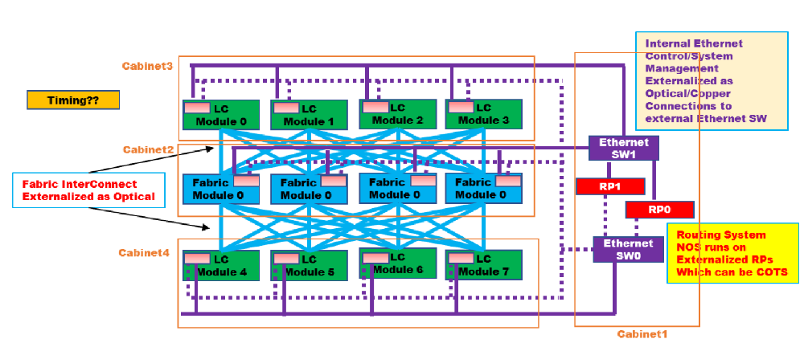
Figure 2- Open Compute Project - Hardware Specifications and Use Case for DDC Routing System

The figure above shows a high-level view of how such a system can be built. In this illustration, the DDC-RS consists of several fixed-RU Pizza boxes that provide ports and of several fixed-RU Pizza boxes that provide Fabric connectivity.

The LCs (Line Cards) are connected to the FM (Fabric Modules) in a non-blocking CLOS model via external high-speed optics. Each FM and LC module has an embedded CPU that runs NOS software subsystems for distributed control and management of the respective module and communicates to the “Master” NOS for this system running on RP0/RP1. The purple-colored external Ethernet switch and connections provide this distributed communications channel. As illustrated, this routing system is implemented over 4 proximity cabinets.

- Open architecture
The RFI hardware (HW) and software (SW) solutions shall comply with the following open-source specifications for a Distributed Disaggregated Chassis (DDC) white box architecture:
  - Open Compute Project (OCP) Distributed Disaggregated Chassis DDC
  - Telecom Infra Project (TIP) Distributed Disaggregated Backbone Router (DDBR)

The hardware and software supplier will need to prove their certification for the standards above; this will allow [Service provider] to:
- Choose an adequate hardware original design manufacturer (ODM) to provide a hardware solution and will also enable hardware components from different suppliers to be interchangeable.

- The software supplier certification will allow choosing adequate software suppliers and seamless software supplier replacement without the need to replace the underly hardware in the network

- Open optics
Supplier shall neither limit nor restrict [SERVICE PROVIDER]’s use of third-party optics in conjunction with supplier’s material. Supplier agrees that [SERVICE PROVIDER]’s use of third-party optics shall not void the warranty on any of the material provided under this agreement.
This section includes all types of optical interfaces and transceivers, including, specifically, ZR/ZR+/Open-XR technology-based optics.

- Scalability

  - Capacity – The prospective supplier shall provide Distributed Disaggregated Chassis Routing System with the ability to automatically add or remove compute or networking infrastructure to support up to 691Tbps.

  - Incremental scale - The prospective supplier shall provide Distributed Disaggregated Chassis Routing System with an elastic incremental scale-up and scale-down mechanize.+

- High availability & Redundancy

Multi-layer redundancy is an important aspect of DDC architecture, aside from reducing the frequency of network changes and failure probability, multi-layer redundancy is also crucial to ensure high network availability.

  - Software Supplier shall ensure high availability, where each service is backed by another. a layered and distributed high availability architecture should combine classic router high-availability features, such as non-stop routing (NSR)/non-stop forwarding (NSF), with microservice internal orchestration and other high-availability mechanisms.
  - Hardware Supplier shall ensure high availability and redundancy of hardware components.

- Cloud-native
  - Software architecture should be cloud native. That is, network functions should run as microservices in containers which will provide isolation of multiple network functions that share the same underlying hardware infrastructure. Such a multi-network-function environment will allow a dynamic allocation of hardware resources such as ports, forwarding resources TCAM resources and compute elements to the different containers/network functions hosted on the shared infrastructure.
  - Multi-vendor containers - the cloud-native architecture shall support the co-existence of network-functions (as containers) from multiple software vendors. For example, the system will be able to accommodate a routing network-function from vendor A and a security network-function (e.g., a DDoS mitigator) from vendor B.

- API (application programming interface)
The system will expose APIs towards 3rd party applications to allow the use of the underlying hardware infrastructure by those applications with minimum integration effort.

- Multiple ASIC support
The system architecture shall be ASIC-agnostic, in the sense that it will not pose any inherent limitation on implementing the suggested architecture across hardware systems that are based on different ASIC technologies, from different ASIC vendors.

- Management & Operations

The prospective Distributed Disaggregated Chassis Routing System shall be designed to allow an end-to-end orchestration framework, which is to be built according to the following:

- Covering multiple deployments and use cases options, e.g., core, access, data center, aggregation, multi-vendors environment, and multiple networking layers (e.g. optical and IP), etc.
- Modular system, rather than monolithic, that uses open, standards-based protocols and interface definitions between modules and towards legacy operational and management systems (OSS/BSS, orchestrators) systems.
- Zero-touch provisioning - automatically integrates multi-vendor hardware and software into a working routing solution.
- Edge Site constraints - The prospective supplier shall embrace a low footprint approach with limited standard building blocks to support any edge base features but also reduce expensive field activities while adapting more easily to site constraints.
- Fast Integration: The prospective supplier shall implement automatic hardware and software integration methods to reduce integration time and the ability to be ready for the production environment with new services or updates.

- Multi-Service over a shared network infrastructure

  - The prospective supplier shall offer combined networking and compute functions, e.q a peering router and a core router on the same hardware\software cluster.
  - The prospective supplier shall offer complete hardware resources sharing (e.g., physical interfaces, NPU, CPU, TCAM, QoS, etc.) across all network functionalities implemented on the same cluster.

- LAB POC\FIELD TRAILS

It is [Service provider]’s objective to execute a lab Proof of Concept (POC) after the conclusions of this RFI are obtained. Such PoC will target some (or all) of the use cases and will be focused on evaluating in the lab the maturity of the selected technologies.

Participants in this RFI are required to participate in such PoC, free of charge, if invited by [Service provider].

They should provide:

- Hardware suppliers: one or two white-boxes per use case in which they are invited, in case different white-boxes have been proposed for different use cases. Otherwise, they can be reused.
- Software suppliers: the required licenses per box on each of the use cases in which they are invited, valid to support the associated functional and performance requirements.
- All suppliers: technical on-site support during the evaluation. The final scope, dates, requirements, etc., of the lab PoC shall be agreed upon after the RFI.

Also, participants in this RFI must take part, free of charge, in potential field
trials in the [Service provider]’s Operations, if invited to do so after the lab PoC.

